Limitations and Observations

1. For some reasons, the site runs faster on Firefox while slower on Chrome.
2. Firefox has problem with displaying responsive table as also stated in Bootstrap site:

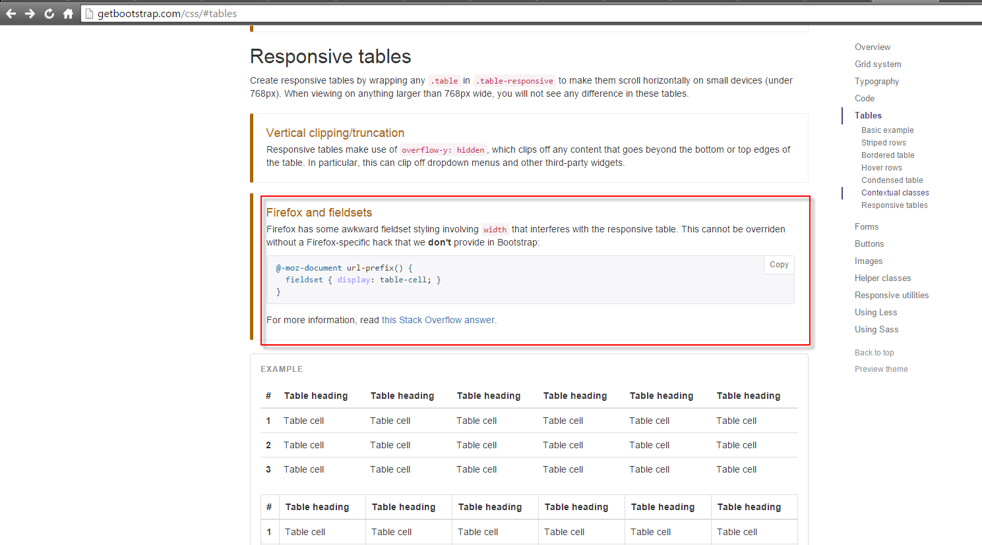

Therefore, if tested on Firefox, the table in my site will not be able to be responsive as on Chrome.

1. Make use of directives:

ng-app, ng-model, ng-repeat, etc. on various places in website.

1. Make uses of services:

$http and $routeProvider to retrieve data from json file and direct to partials. Find out more in app.js and controllers.js

1. Make uses of filter:

Currency, limitedTo. Find out more in list.html and details.html

1. Make uses of data binding:

Filter by on Advert page make uses of data binding.

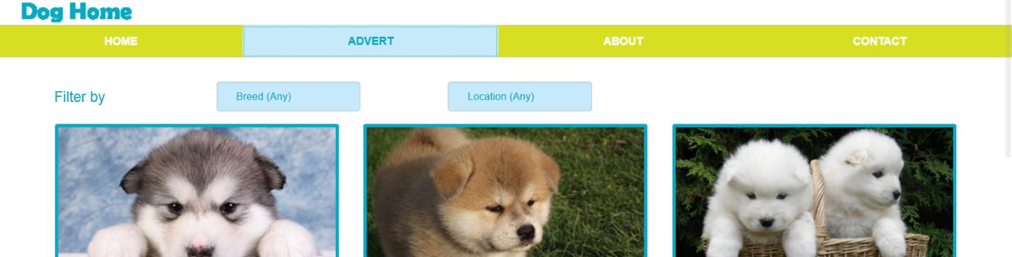

1. Make use of partials:

The site is divided to partials now. You can hover the mouse (on such as Advert, About or Contact on navigation bar) and see the partial link.

1. Make use of templates:

The list, advert, and details partials are templates which data is populated from JSON file. Find out more in list.html, details.html and advert.html

1. I’ve tried to developed **log-in, sign-up** and **add-to-cart** function using angularJS but haven’t finished yet so there is no redirecting happens when clicking on it.

